|  |
| --- |
| **Philly CRM 311**  **Technical Design – Street Light Outage**  **V1.1** |
|  |

# REVISION HISTORY

|  |  |  |  |
| --- | --- | --- | --- |
| **Revision Number** | **Revision Date** | **Summary of Changes** | **Author** |
| Draft | 01/26/2014 | Created Draft | Murugaboopathi |
| 1.0 | 02/10/2014 | Updated based on review and updated requirement | Murugaboopathi |
| 1.1 | 04/14/2014 | Updated based on review and updated requirement 1.10 | Murugaboopathi |

# 1 - TABLE OF CONTENTS

REVISION HISTORY 2

1 - TABLE OF CONTENTS 3

2 – SERVICE REQUEST INFORMATION 4

2.1 ENTITY RELATIONSHIP DIAGRAM 5

2.2.1 CASE STANDARD FIELDS FOR STREET LIGHT OUTAGE 5

2.2.2 CASE ADDITIONAL FIELDS FOR STREET LIGHT OUTAGE 6

2.3 HIGH LEVEL SYSTEM PROCESS FLOW 9

3 - NEW FUNCTIONALITY 10

3.1 CONFIGURATION DETAILS 10

3.2 DATA SHARING MODEL 15

3.3 CUSTOM DEVELOPMENT DETAILS 16

4 – STANDARD CASE FIELDS 20

4.1 DEPARTMENT DETAILS SECTION 20

4.2 CASE DETAIL/INFORMATION SECTION 22

4.3 SERVICE REQUEST LOCATION SECTION 24

4.4 CASE LOCATION SECTION 25

4.5 DESCRIPTION INFORMATION SECTION 25

4.6 RESOLUTION INFORMATION SECTION 26

4.6 WEB INFORMATION SECTION 27

4.7 SYSTEM INFORMATION SECTION 27

# 2 – SERVICE REQUEST INFORMATION

|  |  |
| --- | --- |
| **Case Record Type :** | Street Light Outage |
| **Service Request ID** | SR-ST04: Street Light Outage |
| **Service Request Type** | Street Light Outage |
| **Department** | Streets |

|  |
| --- |
| 2.1 ENTITY RELATIONSHIP DIAGRAM |

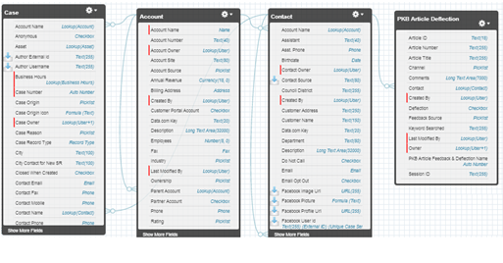

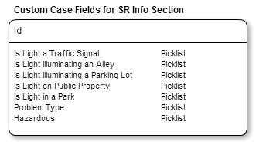

|  |
| --- |
| 2.2.1 CASE STANDARD FIELDS FOR STREET LIGHT OUTAGE |

|  |  |  |  |  |  |  |  |  |  |
| --- | --- | --- | --- | --- | --- | --- | --- | --- | --- |
| **Field Label** | **Field Name** | **Data Type** | **Required** | **Unique** | **Default Value** | **External ID** | **Rule #** | **History** | **Help Text** |
| Status | Status | Picklist  Values:  New, In-Progress, Escalated, On Hold, and Closed | Yes | No | New | No | None | Yes |  |
| Case Origin | Origin | Picklist  Values:  Phone, Email, Web | Yes | No | Phone | No | None | Yes |  |
| Priority | Priority | Picklist  Values:  High, Medium, Low | Yes | No | Medium | No | None | Yes |  |

|  |
| --- |
| 2.2.2 CASE ADDITIONAL FIELDS FOR STREET LIGHT OUTAGE |

|  |  |  |  |  |  |  |  |  |  |
| --- | --- | --- | --- | --- | --- | --- | --- | --- | --- |
| **Field Label** | **Field Name** | **Field Type** | **Required** | **Unique** | **Default Value** | **External ID** | **Rule #** | **History** | **Field Help Text** |
| Is Light a Traffic Signal | Is_the_Light_a_Traffic_Signal__c | Picklist  **Values:** Yes, No | Yes |  |  |  | Workflow Rule #1 | No | Is the light a red, yellow, and green traffic signal at an intersection? |
| Is Light Illuminating an Alley | Is_Light_Illuminating_an_Alley__c | Picklist  **Values:** Yes, No | Yes |  |  |  | Workflow Rule #2 | No | Is the light in front of the property not on the street rather than in an alley or driveway? |
| Is Light Illuminating a Parking Lot | Is_the_Light_Illuminating_a_Street__c | Picklist  **Values:** Yes, No | No |  |  |  | Workflow Rule #10 | No | Is the light illuminating a Parking Lot? |
| Is Light on Public Property | Is_Light_on_Public_Property__c | Picklist  **Values:** Yes, No | No |  |  |  | Workflow Rule #4 |  | Is it belonging to Public Property? |
| Is Light in a Park | Is_Light_on_Public_Property__c | Picklist  **Values:** Yes, No | Yes |  |  |  | Workflow Rule #3 | No | Is the light in a park, refer to GIS? |
| Problem Type | Problem_Type__c | Picklist  **Values:** Bulb Hanging, On All the Time, On and Off, On During Day, Out All the Time, Pole Down, Pole Leaning, Wire Down, Wires Sparking,  Request for New Lighting, Other | Yes |  |  |  | Workflow Rule #5  Workflow Rule #6 | No | The type of problem that is causing the street light outage. |
| Hazardous | Hazardous__c | Picklist  **Values:** Yes, No | Yes |  |  |  | Workflow Rule #7, Workflow Rule #8 | No | Auto-filled |

|  |  |  |
| --- | --- | --- |
| **Custom/Standard** | **Existing Objects** | **New Objects** |
| Standard | Case |  |
| Standard | Account |  |
| Standard | Contact |  |
| Custom | PKB Article Deflection |  |

|  |
| --- |
| 2.3 HIGH LEVEL SYSTEM PROCESS FLOW |



# 3 - NEW FUNCTIONALITY

|  |
| --- |
| 3.1 CONFIGURATION DETAILS |

**Case Record Type:** Street Light Outage

Label: Street Light Outage

Support Process: [Street light outage](https://cs10.salesforce.com/setup/ui/bpfields.jsp?id=019J00000008VNK&retURL=%2Fsetup%2Fui%2Fbplist.jsp%3Fid%3D500%26setupid%3DCaseProcess%26retURL%3D%252Fui%252Fsetup%252FSetup%253Fsetupid%253DCase&setupid=CaseProcess)

Support Process Selected Values:

* New (Default)
* In-Progress
* Escalated
* On-Hold
* Closed(Closed)

Record Type Name: Street_Light_Outage

**Buttons:**

* Case Edit
  + Save
  + Save & Close
  + Cancel
* Case Detail
  + Edit
  + Delete
  + Close Case
  + Clone

**Tab Setup:**

**App Setup:**  Call Center Console

**User Profile Setup:**

* 311 Agents
* 311 Supervisors
* Case Workers
* System Administrators

**Permission Set Setup:** Please refer Profile & Permission Setup and Profile technical design.

**Role Hierarchy Considerations:** TBD

**Workflows:**

| **Rule #** | **Rule Name** | **Workflow Action** | **Rule Criteria** | **Object** | **Evaluation Criteria** |
| --- | --- | --- | --- | --- | --- |
| 1 | Workflow Rule *Is Light a Traffic Signal* | Display message: “The system has changed the Case Record Type to Traffic Signal Emergency.”  Automatically change the *Case Record Type* = ‘Traffic Signal Emergency’. | *Is Light a Traffic Signal* = ‘Yes’ |  | Evaluate the rule when a record is created, and every time it’s edited. |
| 2 | Workflow Rule *Is Light Illuminating an Alley* | Display message: “The system has changed the Case Record Type to Alley Light Outage.”  Automatically change the *Case Record Type* = ‘Alley Light Outage’. | *Is Light Illuminating an Alley* = ‘Yes’ |  | Evaluate the rule when a record is created, and every time it’s edited. |
| 3 | Workflow Rule *Is Light in a Park?* | Display message: “The system has changed the Case Record Type to Park Conditions Safety and Maintenance.”  Automatically change the *Case Record Type* = ‘Park Conditions Safety and Maintenance’. | *Is Light in a Park* = ‘Yes’ |  | Evaluate the rule when a record is created, and every time it’s edited. |
| 4 | Workflow Rule for Is Light on *Public Property* | Display message: “The system has changed the Case service request type to Public Property. Provide the caller with Owner’s information and caller will get informational email.”  Automatically set *Service Request Type* to “Service Not Needed’ and save the case.  Automatically assign the case and then close it with a *Close Reason* = “Service Not Needed”. | *Is Light on Public Property* = ‘Yes’ |  | Evaluate the rule when a record is created, and every time it’s edited. |
| 5 | Workflow Rule for *Problem Type* Other | Automatically change the *Service Request Type* = ‘Street Light (Other)’. | *Problem Type* = ‘Other’ or ‘Request for New Lighting’ |  | Evaluate the rule when a record is created, and every time it’s edited. |
| 6 | Workflow Rule for *Problem Type* Not Other | Automatically set the *Service Request Type* = ‘Street Light Outage’. | *Problem Type* is NOT null and is NOT ‘Other’ or ‘Request for New Lighting” |  | Evaluate the rule when a record is created, and every time it’s edited. |
| 7 | Workflow Rule for *Hazardous* | Then *Hazardous* = ‘Yes”. Else, *Hazardous* = ‘No’. | If *Problem Type* = Bulb Hanging OR Pole Down OR Wire Down OR Wires Sparking |  | Evaluate the rule when a record is created, and every time it’s edited. |
| 8 | Workflow Rule for *Municipal Radio* | Generate email to Municipal Radio. | *Hazardous* = ‘Yes’ |  | Evaluate the rule when a record is created, and every time it’s edited. |
| 9 | Workflow Rule for *Redress* | Set Case Status = ‘Redress’ | If *Case Status* = ‘Closed’ AND Current Date – Case Opened Date <= 30 |  | Evaluate the rule when a record is created, and every time it’s edited. |
| 10 | Workflow Rule for *Is Light Illuminating a Parking Lot* | Display message: “Refer to BRT to obtain ownership and give information to caller. Inform caller that the light is the owner’s responsibility”  Automatically set *Service Request Type* to “Service Not Needed’ and save the case.  Automatically assign the case and then close it with a *Close Reason* = “Service Not Needed”. | *Is Light Illuminating a Parking Lot* = ‘Yes’ |  | Evaluate the rule when a record is created, and every time it’s edited. |

**Approval Processes:**

**Reports & Dashboards:**

**Validation Rules**:

|  |  |  |  |
| --- | --- | --- | --- |
| **Rule No** | **Rule Name** | **Conditions** | **Message** |
|  |  |  |  |

**Queues :** *CONTRACTOR Queue*

**Queue Members :** Richard Montanez

**Queues Conditions :**If the case is new then assign to *CONTRACTOR Queue*

**Email Notifications:**

1. if the Agent is selected “Send Notification Email to Contact” checkbox then

Email send to Contact using “Case Creation” template.

1. If Hazardous only, send an email to Municipal radio

**Public Groups:**

**Sharing Rules:**

|  |  |  |  |
| --- | --- | --- | --- |
| **Rule Name** | **Criteria** | **Shared With** | **Access Level** |
|  |  |  |  |
|  |  |  |  |
|  |  |  |  |

**Custom Report Types:**

**Chatter Enabled Objects:**

**Documents And Attachments** :

**Flow/Agent Instructions(Left side of the Layout)**:

|  |
| --- |
| * The City of Philadelphia Graffiti Abatement Team (GAT) provides homeowners, businesses and community organizations with free powerwash and painting services to combat graffiti vandalism from their respective properties and neighborhood. Graffiti removal normally takes place 7 business days from the time it is reported, depending on weather conditions. * The Graffiti Abatement Team cannot remove graffiti under the following conditions:   + Above the first floor on private property, the owner is responsible for removing the graffiti.   + Along the Amtrak, Conrail or SEPTA rail corridors refer the customer to the responsible authority to request graffiti removal.   + Oil spills, grease stains, utility markings or spilled paint from properties are not graffiti related.   + “Acid etch” from windows. The customer can hire a private contractor who specializes in acid etch removal or replace the damaged window.   + Schools and recreation centers when children are not present for safety reasons.   + During temperatures below 40 degrees because it freezes the equipment. * The Graffiti Abatement Team is not responsible for removal in the following areas and callers should be directed to the proper contact listed:   + **Graffiti in Center City:**refer the customer to the Center City District (CCD) at (215) 440-5500.  The Center City District boundaries may be reviewed at  <http://www.centercityphila.org/docs/CCDBoundaryMap.pdf>   + **Public Schools:**215-400-6434   + **News Stands:**610-800-6455   + **Newspaper Boxes:**610-292-6312   + **Mailboxes:**215-895-8610   + **SEPTA Bridges:**215-580-7800   + **PGW Property:**215-684-6288   + **PECO Property:**800-494-4000 (press 0)   + **Verizon Phones:**800-782-8355 * More detailed information about the Graffiti Abatement Team and other blight related services can be found on www.phila.gov/qualityoflife |

|  |
| --- |
| 3.2 DATA SHARING MODEL |

|  |  |  |  |
| --- | --- | --- | --- |
|  | ***User Types*** | ***Permission Sets*** | ***Public Groups*** |
| *LEVEL 1* |  |  |  |
| *LEVEL 2* |  |  |  |
| *LEVEL 3* |  |  |  |

|  |
| --- |
| 3.3 CUSTOM DEVELOPMENT DETAILS |

**Visualforce Pages**

* For Case Location Section in Case Detail: Create a VF Page which will use SR Location to depict Street,City,State in a Map.

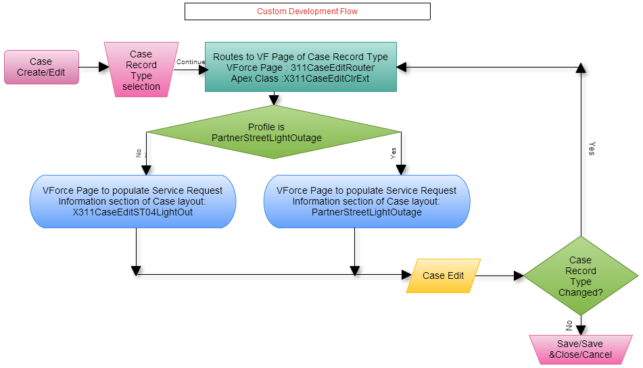

**Custom Flow :** For standard button New/Edit button is replaced with a custom Visualforce Page **X311CaseEditRouter**. All the Visual force pages and related extensions are defined as follows.

**Visual Force Page : X311CaseEditRouter**

**Purpose:**  To route to SR specific Visual force page.

<apex:page standardcontroller="Case" extensions="X311CaseEditClrExt" action="{!redir}">

</apex:page>

**Apex Class : X311CaseEditClrExt**

public PageReference redir() {

* + - 1. Get current page parameters.
      2. Get the relevant Page depending on the Profile and Record Type(X311CaseEditNS01Graffiti or PartnerGraffitiRemoval)..
      3. Redirect to the page with parameters.

}

**Visual Force Page : X311CaseEditST04LightOut**

<apex:page standardcontroller="Case">

<apex:composition template="X311CaseEdit">

<apex:define name="typeSpecific">

<apex:pageblocksection title="Service Request Information" showheader="true" collapsible="true" columns="2">

**STREET LIGHT OUTAGE SPECEFIC FIELDS**

</apex:pageblocksection>

</apex:define>

</apex:composition>

</apex:page>

**Visual Force Page : X311CaseEdit**

<apex:page standardcontroller="Case" extensions="X311CaseEditClrExt">

<apex:pageblock mode="edit">

<apex:pageblocksection title="Department Details">

</apex:pageblocksection>

<apex:pageblocksection title="Case Information">

</apex:pageblocksection>

<apex:pageblocksection title="Service Request Location">

</apex:pageblocksection>

<apex:inputTextArea id="caseInternalComments" >

</apex:pageblocksection>

<apex:pageblocksection title="Description Information">

</apex:pageblocksection>

<apex:pageblock>

</apex:page>

**Visual Force Page : PartnerStreetLightOutage**

<apex:page standardcontroller="Case" extensions="X311CaseEditClrExt">

<apex:pageblock mode="edit">

<apex:pageblocksection title="Department Details">

</apex:pageblocksection>

<apex:pageblocksection title="Case Information">

</apex:pageblocksection>

<apex:pageblocksection title="Service Request Location">

</apex:pageblocksection>

<apex:inputTextArea id="caseInternalComments" >

</apex:pageblocksection>

<apex:pageblocksection title="Service Request Information" showheader="true" collapsible="true" columns="2">

**STREET LIGHT OUTAGE SPECEFIC FIELDS**

</apex:pageblocksection>

<apex:pageblocksection title="Description Information">

</apex:pageblocksection>

<apex:pageblock>

</apex:page>

* **Triggers:**

|  |  |  |
| --- | --- | --- |
| **Trigger Name** | **Object** | **Description** |
| CalculateBusinessHoursAges | Case | Calculates the total business hours between when a case was opened and when it was closed and then populates “Case Age in Business Hours” field, which is displayed in the “Age to Close in Business Hours” field shown within the “Resolution Information” section of the case |
| Account_Name_Update | Contact | When a new Contact is created during the case creation process, the system does not allow for an Account to be associated to the Contact, yet Account is a required field for a Contact. Whenever a new Contact is created without an Account, this trigger will associate the Account record with Name = “City of Hampton” to the Contact record |

**Apex Code:**

**Force.com sites:**

**Javascripts:**

**Web Service/API Code:**

**Customer Portals:**

**Communities:** Community Partner Self-Service Portal

**Site.com:**

**Third Party Applications:**  Survey Force, Sales for Social Media & Call Center Console

**Other:**

**Layout:** Street Light Outage

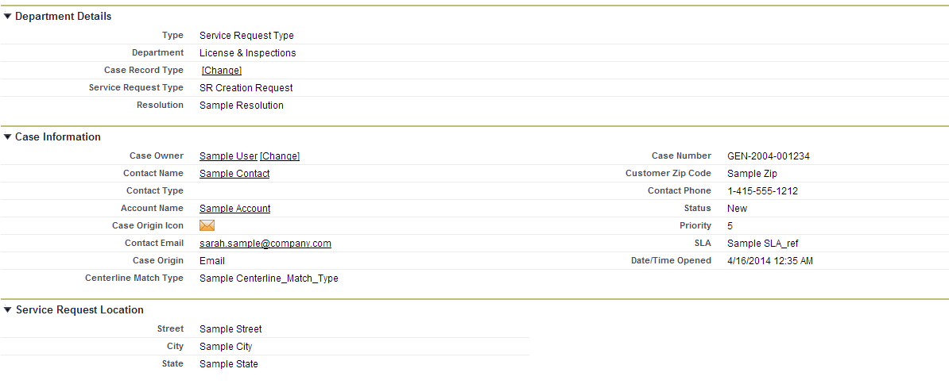

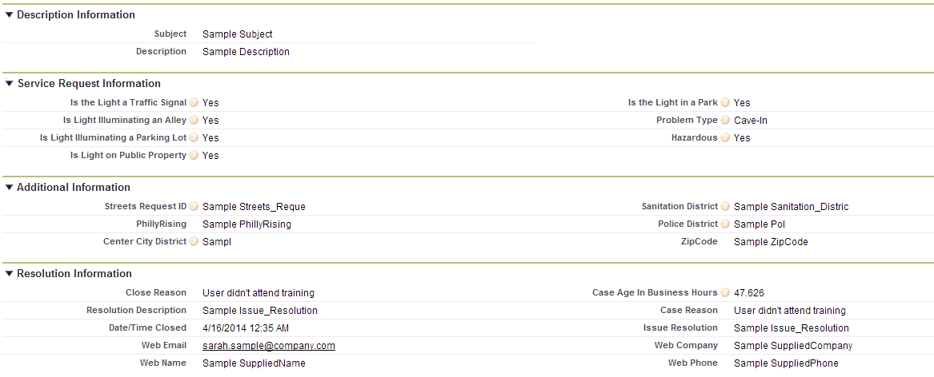



Related Lists :

Articles

Related Cases

Open Activities

Activity History

Case Comments

Case History

Attachments

# 4 – STANDARD CASE FIELDS

|  |
| --- |
| 4.1 DEPARTMENT DETAILS SECTION |

|  |  |  |  |  |  |  |  |  |  |  |  |
| --- | --- | --- | --- | --- | --- | --- | --- | --- | --- | --- | --- |
| **Field Label** | **Field Name** | **Field Type** | **Custom** | **Default** | **Required** | **Unique** | **Read Only** | **External ID** | **Validation** | **History** | **Comments** |
| Type | Type | Picklist  **Values:** Service Request Type, Information Request Type, Directory Services | N | Service Request Type | Y |  | N | N | None | Y | Field is initially auto-populated based on the Case Record Type being created. If this value is manually changed, it will result in a new Field Layout based on the new Case Record Type. |
| Department | Department__c | Picklist  **Values:** Neighborhood Services | Y | Service Request Type | Y |  | N |  | None | N | Department will be automatically set based on Service Request Type. For an Information Request, this field will be automatically populated by the article. For Directory Services the field will default to 311 Services. |
| Service Request Type | Service_Request_Type__c | Picklist  **Values:** Graffiti Removal | Y | Graffiti Removal | Y |  | N |  | None | Y | This field is initially auto-populated based on the Case Record Type chosen when creating the case. If this value is changed, it could result in a new Field Layout based on the new Case Record Type chosen.  If any value in the Other Case Information systems indicates that this should not be forwarded to another department as a Service Request, a value of “Request Not Required” will be assigned to this field, which will indicate that the Case should be closed upon save without being assigned to a queue. |

|  |
| --- |
| 4.2 CASE DETAIL/INFORMATION SECTION |

**NOTE :** Section Header has to be “Case Information” in the layout when case is created or opened for modification. Other wise, Section Header is “Case Detail” .

| **Field Label** | **Field Name** | **Field Type** | **Custom** | **Default** | **Required** | **Unique** | **Read Only** | **External ID** | | **Validation** | **History** | **Comments** |
| --- | --- | --- | --- | --- | --- | --- | --- | --- | --- | --- | --- | --- |
| Case Owner | Owner | Lookup(User,Queue) | N |  | N |  | N | N | None | | Y | When a case is created this field is set to the User creating the case. Upon save, the Standard Case Assignment Rule is executed and this field is updated to a Queue based on the case’s Service Request Type. Once the case is saved this field can be manually changed by a user. |
| Case Number | CaseNumber | Auto Number | N |  | N | Y | Y | N | None | | N | The system automatically populates this field when a case is created. |
| Caller Zip Code | Caller_zip_code__c | Lookup(Contact) | Y |  | Y |  | N | N | None | | Y | This field will be populated by the Zip Code in the Contact record if one is associated with the case, otherwise the agent may populate it with a number from the caller. |
| Contact Name | Contact | Lookup(Account) | N |  | N |  | N | N | None | | Y | This field contains the Contact requesting the service. Ideally every case should have an associated contact. |
| Account Name | Account | Lookup(Account) | N |  | N |  | N | N | None | | N | This field contains the Account associated with the Contact record. |
| Parent Case | Parent | Lookup(Account) | N |  | N |  | N | N | None | | N | Two cases can be associated to each other via a parent/child relationship. This field identifies the “Parent” case. “Child” cases are displayed in the “Related Cases” Related List section for the “Parent” case. |
| Case Origin icon | Origin | Formula(Text) | Y |  | N |  | Y | N | None | | N | Shows an image representing the value in the Case Origin field. The formula for this field is: IMAGE(  CASE( Origin,  "Email", "https://<SalesforceOrg>.content.force.com/servlet/servlet.FileDownload?file=015K0000000238q",  "Phone", "https://<SalesforceOrg>.content.force.com/servlet/servlet.FileDownload?file=015K0000000238R",  "Web", "https://<SalesforceOrg>.content.force.com/servlet/servlet.FileDownload?file=015K000000023QL",  "/s.gif"),  "Origin Flag") |
| Contact Phone | ContactPhone | Phone | N |  | N |  | Y | N | None | | N | This display-only field is from the “Phone” field on the Contact record associated to the case. |
| Contact Email | ContactEmail | Email | N |  | N |  | Y | N | None | | N | This display-only field is from the “Email” field on the Contact record associated to the case. |
| Status | Status | Picklist  **Values:** On Hold, Escalated, Closed, New, In-Progress | N | New | Y |  | N | N | None | | Y | This required field defines the status of the case.   * “New” is the default value when creating a case. * All values except “Closed” are available when creating or editing a case.   “Closed” is the only value that can be selected when the “Close Case” button is used. |
| Case Origin | Origin | Picklist  **Values:** Email, Phone, Web | N | Phone |  | Y | N | N | None | | Y | This optional field provides the in-depth description of the case. |
| Priority | Priority | Picklist  **Values:** 1,2,3,4,5,6,7,8,9 | N | 5 |  | N | N | N | None | | N | This field allows a user to easily create a Comment while creating or editing a case. The data entered in this field will be used by the system to create a Comment record that will be displayed in the “Case Comments” Related List section of the case. |

## 

|  |
| --- |
| 4.3 SERVICE REQUEST LOCATION SECTION |

|  |  |  |  |  |  |  |  |  |  |  |  |
| --- | --- | --- | --- | --- | --- | --- | --- | --- | --- | --- | --- |
| **Field Label** | **Field Name** | **Field Type** | **Custom** | **Default** | **Required** | **Unique** | **Read Only** | **External ID** | **Validation** | **History** | **Comments** |
| Street | Street__c | Text(255) | Y |  | N |  | N |  |  |  | Street of the Service Request Location. Also see Standard Workflow Rules. |
| City | City__c | Text(255) | Y |  | N |  | N |  |  |  | City of the Service Request Location. Also see Standard Workflow Rules. |
| State | State__c | Text(255) | Y |  | N |  | N |  |  |  | State of the Service Request Location. Also see Standard Workflow Rules. |

|  |
| --- |
| 4.4 CASE LOCATION SECTION |

Defined in GIS Integration Detailed Design Document.

|  |
| --- |
| 4.5 DESCRIPTION INFORMATION SECTION |

|  |  |  |  |  |  |  |  |  |  |  |
| --- | --- | --- | --- | --- | --- | --- | --- | --- | --- | --- |
| **Field Label** | **Field Name** | **Field Type** | **Custom** | **Default** | **Required** | **Read Only** | **External ID** | **Validation** | **History** | **Comments** |
| Subject | Subject | Text(255) | N |  | Y | N |  |  | Y | If this field is populated when creating a new case, the system will find and display Knowledgebase Articles using the content in the “Subject” field. |
| Description | Description | Long Text Area(32000) | N |  | Y | N |  |  | Y | This optional field provides the in-depth description of the case. |
| Internal Comments | Comments | Text Area(4000) | N |  | N | N |  |  | N | This field allows users to enter a Comment while creating or editing a case. Data entered in this field will be used by the system to create a Comment record that will be displayed in the “Case Comments” Related List section of the case. |

|  |
| --- |
| 4.6 RESOLUTION INFORMATION SECTION |

NOTE: Case Detail page have these fields only be populated if the case is “closed”.

| **Field Label** | **Field Name** | **Field Type** | **Custom** | **Default** | **Required** | **Read Only** | **External ID** | **Validation** | **History** | **Comments** |
| --- | --- | --- | --- | --- | --- | --- | --- | --- | --- | --- |
| Close Reason | Close_Reason__c | Formula (Text) Formula : TEXT(Reason) | Y |  | N | Y |  |  | N |  |
| Resolution Description | Resolution_Description__c | Formula (Text) Formula : TEXT(Issue_Resolution__c) | Y |  | N | Y |  |  | N |  |
| Date/Time Closed | ClosedDate | Date/Time | N |  | N | Y |  |  | N |  |
| Age to Close in Business Hours | Age_to_Close_in_Business_Hours__c | Formula(Number) | Y |  | N | Y |  |  | N | CalculateBusinessHoursAges trigger would update this field |
|  |  |  |  |  |  |  |  |  |  |  |

NOTE: Following fields is shown in Resolution Info section.

|  |  |  |  |  |  |  |  |  |  |  |
| --- | --- | --- | --- | --- | --- | --- | --- | --- | --- | --- |
| **Field Label** | **Field Name** | **Field Type** | **Custom** | **Default** | **Required** | **Read Only** | **External ID** | **Validation** | **History** | **Comments** |
| Case Age in Business Hours | Case_Age_In_Business_Hours__c | Number(15,3) | N |  | N | Y |  |  | Y | CalculateBusinessHoursAges trigger would update this field |
| Case Reason | Reason | Picklist Values: Emergency Call, Invalid, Other, Question Answered | N | Question Answered | Y | N |  |  | Y |  |
| Issue Resolution | Issue_Resolution__c | Text Area(255) | Y |  | N | N |  |  | Y |  |

## 

|  |
| --- |
| 4.6 WEB INFORMATION SECTION |

NOTE: Section is shown only when the case is created through social media channels.

| **Field Label** | **Field Name** | **Field Type** | **Custom** | **Default** | **Required** | **Read Only** | **External ID** | **Validation** | **History** | **Comments** |
| --- | --- | --- | --- | --- | --- | --- | --- | --- | --- | --- |
| Web Email | SuppliedEmail | Email | N |  | N | Y |  |  | N |  |
| Web Name | SuppliedName | Text(80) | N |  | N | Y |  |  | N |  |
| Web Company | SuppliedCompany | Text(80) | N |  | N | Y |  |  | N |  |
| Web Phone | SuppliedPhone | Text(40) | N |  | N | Y |  |  | N |  |

|  |  |  |  |  |  |  |  |
| --- | --- | --- | --- | --- | --- | --- | --- |
| 4.7 SYSTEM INFORMATION SECTION | | | | | | | |
| **Field Label** | | **Field Name** | **Field Type** | **Custom** | **Default** | **Required** | **Read Only** | **External ID** | | **Validation** | **History** | **Comments** |
| Created By | | CreatedBy | Lookup(User) | N |  | N | Y |  | |  | N |  |
| Last Modified By | | LastModifiedBy | Lookup(User) | N |  | N | Y |  | |  | N |  |

Additional comments: